|  |  |
| --- | --- |
| **20CS2032L – MACHINE LEARNING TECHNIQUES** | **URK22AI1048** |

|  |  |
| --- | --- |
| **EXERCISE** | **8. SELF ORGANIZING MAPS** |
| **DATE** | **17.09.2024** |

**AIM:**

To implement Self Organizing Map (SOM) to cluster the given data points.

**DESCRIPTION**: It follows an unsupervised learning approach and trained its network through a competitive learning algorithm. SOM is used for clustering and mapping (or dimensionality reduction) techniques to map multidimensional data onto lower-dimensional which allows people to reduce complex problems for easy interpretation. SOM has two layers, one is the Input layer and the other one is the Output layer.

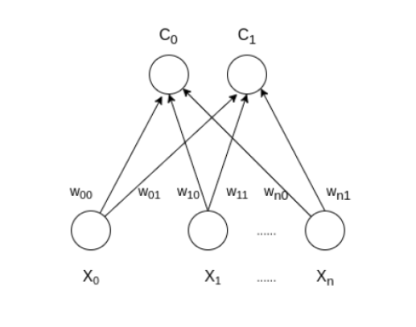

*Weight updation rule is given by:*wij = wij(old) + alpha(t) * (xik - wij(old))

**Training:**

Step 1: Initialize the weights wij random value may be assumed. Initialize the learning rate α.

Step 2: Calculate squared Euclidean distance.

*D(j) = Σ (wij – xi)^2    where i=1 to n and j=1 to m*

Step 3: Find index J, when D(j) is minimum that will be considered as winning index.

Step 4: For each j within a specific neighborhood of j and for all i, calculate the new weight.

*wij(new)=wij(old) + α[xi – wij(old)]*

Step 5: Update the learning rule by using :

*α(t+1) = 0.5 * t*

Step 6: Test the Stopping Condition.

**PROGRAM**:

import numpy as np

import matplotlib.pyplot as plt

import math

class SOM:

    def __init__(self, m, n, num_clusters, alpha=0.5, epochs=100):

        """

        Initialize the SOM with the given dimensions, number of clusters,

        learning rate, and number of epochs.

        """

        self.m = m  # Rows (number of neurons in the grid)

        self.n = n  # Columns (number of neurons in the grid)

        self.num_clusters = num_clusters  # Number of neurons/clusters

        self.alpha = alpha  # Learning rate

        self.epochs = epochs  # Number of epochs

        # Initialize weights (random values between 0 and 1)

        # Now initializing weights for 2 features (same as input data)

        self.weights = np.random.rand(num_clusters, 2)

        self.grid_shape = (m, n)

    def winner(self, sample):

        """

        Compute the Euclidean distance between the sample and each weight vector.

        The weight vector with the minimum distance is the winning neuron (cluster).

        """

        distances = np.linalg.norm(self.weights - sample, axis=1)

        return np.argmin(distances)  # Index of the minimum distance

    def update(self, sample, winner_index):

        """

        Update the weights of the winning neuron.

        """

        self.weights[winner_index] += self.alpha * (sample - self.weights[winner_index])

    def train(self, data):

        """

        Train the SOM using the given data for a number of epochs.

        """

        for epoch in range(self.epochs):

            # For each sample, find the winning neuron and update the weights

            for sample in data:

                winner_index = self.winner(sample)

                self.update(sample, winner_index)

            # Optionally decay the learning rate over time

            self.alpha = self.alpha * (1.0 - epoch / float(self.epochs))

            # Plot the weights at the end of each epoch to visualize the training

            if epoch % 10 == 0:  # Visualize every 10 epochs

                self.plot_weights(epoch)

    def plot_weights(self, epoch):

        """

        Plot the weights of the SOM at each epoch.

        """

        plt.figure(figsize=(8, 6))

        plt.title(f'SOM Weights at Epoch {epoch + 1}')

        plt.scatter(self.weights[:, 0], self.weights[:, 1], s=100, c='blue', label='Clusters')

        plt.xlabel('Weight Index 1')

        plt.ylabel('Weight Index 2')

        plt.legend()

        plt.show()

# Driver code to demonstrate SOM

def main():

    # Sample training data (4 samples, 2 features)

    data = np.array([[1, 1], [0, 0], [1, 0], [0, 1]])

    # Define the size of the SOM grid (2x2 grid)

    m = 2  # Rows

    n = 2  # Columns

    num_clusters = 2  # Number of clusters

    som = SOM(m, n, num_clusters, alpha=0.5, epochs=50)

    som.train(data)

    test_sample = np.array([0.8, 0.8])  # Example test sample

    winner_index = som.winner(test_sample)

    print(f'Test sample {test_sample} belongs to Cluster: {winner_index}')

if __name__ == "__main__":

    main():

**OUTPUT:**

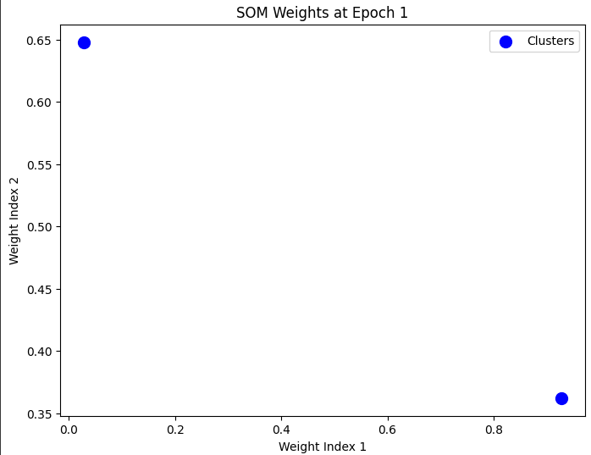

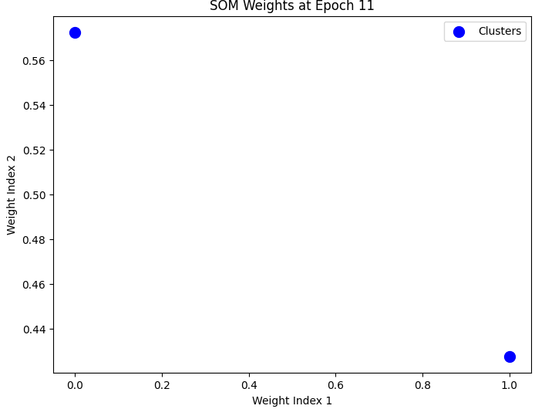

**RESULT:**

The above code is executed successfully using self- organizing maps.